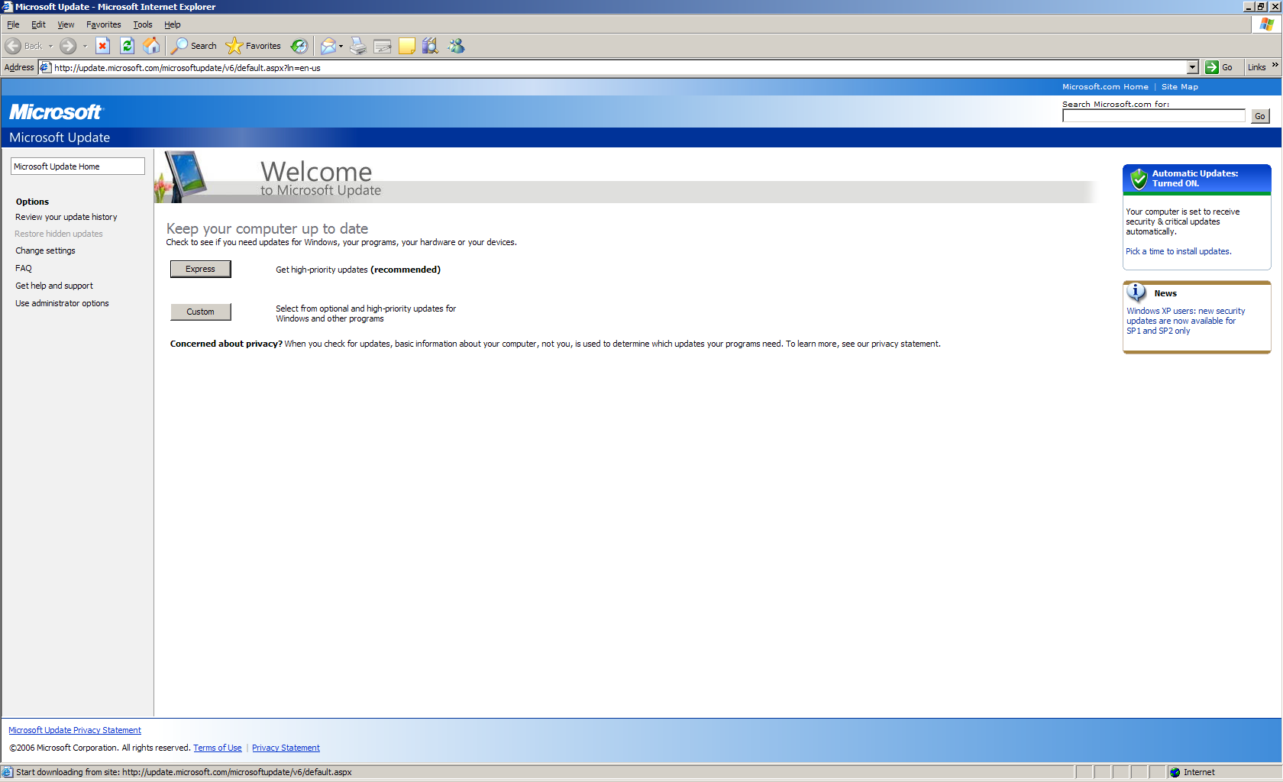
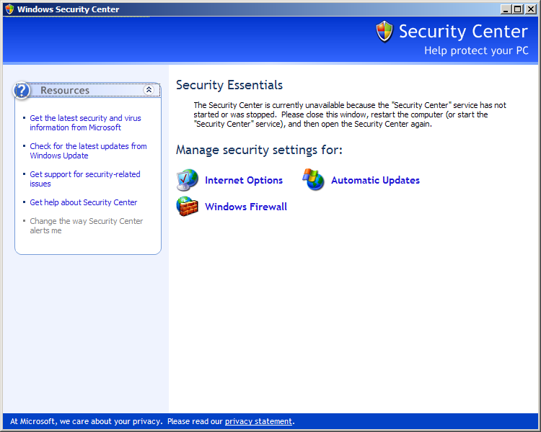

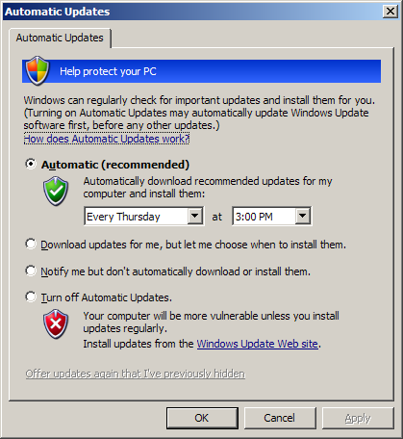
Summary
Windows Update is a no-brainer. I'm always up to date. One thing I will note is that I disable the Security Center service when I kill unneeded services, because I don't need an annoying program telling me that I need to install a firewall / install anti-virus software / enable automatic updates. Once I do those things, the service has no purpose running whatsoever. So I kill it. I also didn't go and pick the option to notify me but don't automatically download/install because I personally think that option is stupid. The update should happen as soon as possible, especially with all of the 0day attacks going around lately.

